1.Created user with name techie01 and provided sudo access to user.
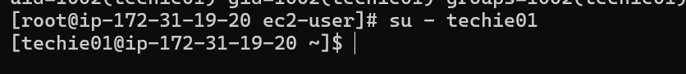
2: Navigate to Home Directory
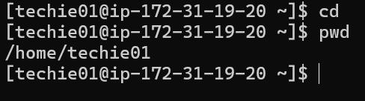
3.Create New Directory
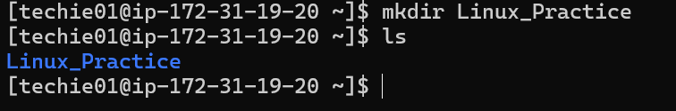
4: List Contents of Directory
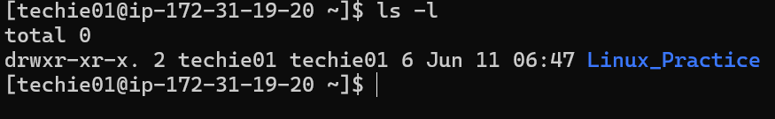
5: Change Current Directory
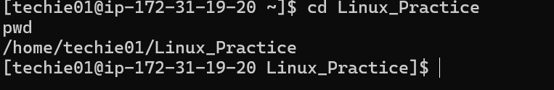
6: Create New Empty File
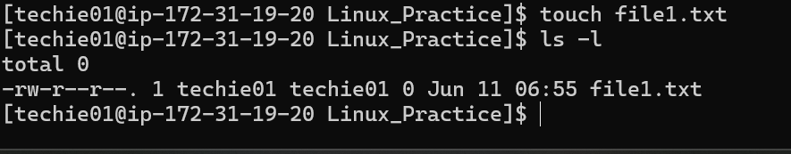

7: View Contents of File
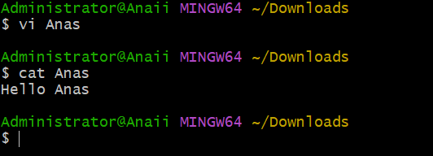
8: Copy File
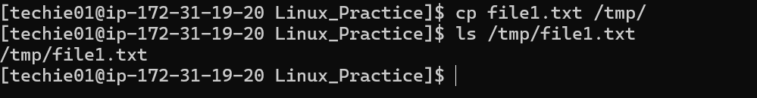
9: Move File
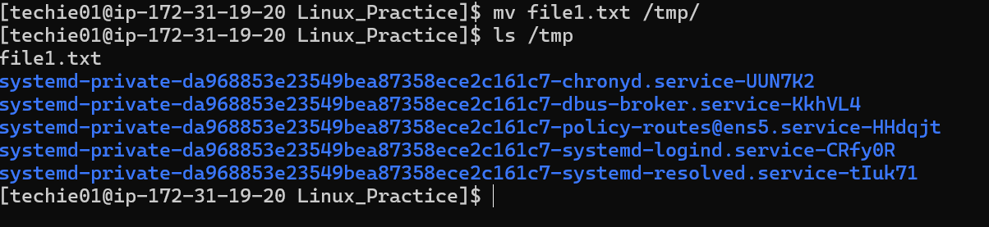
10: Rename File
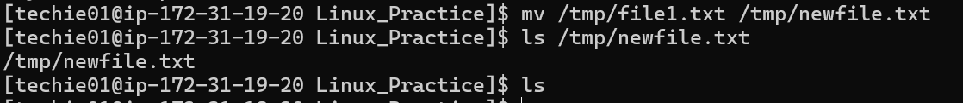
11: Delete File
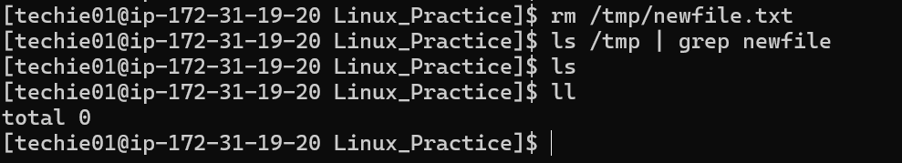
12: Grant/Revoke Permissions
After change
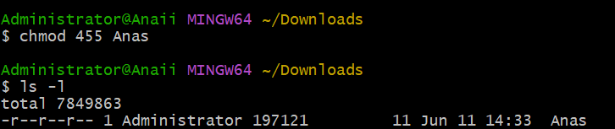
13: Current Date and Time
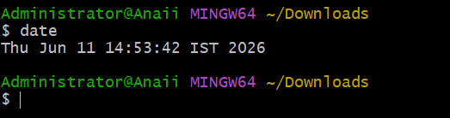
14: System Uptime
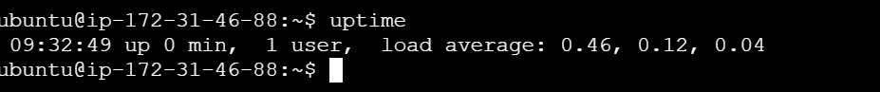
15: View Running Processes
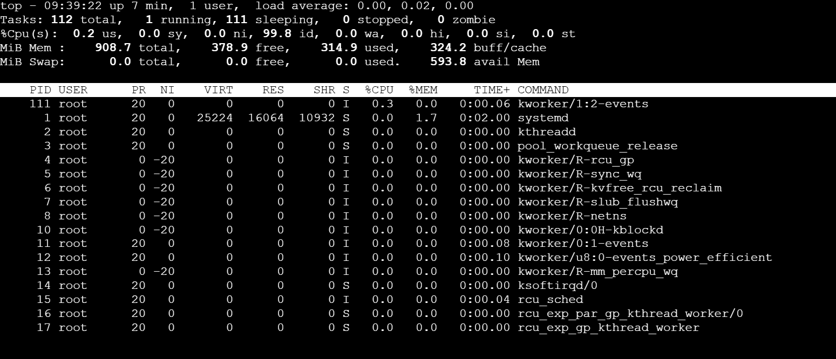
16: Kill Process

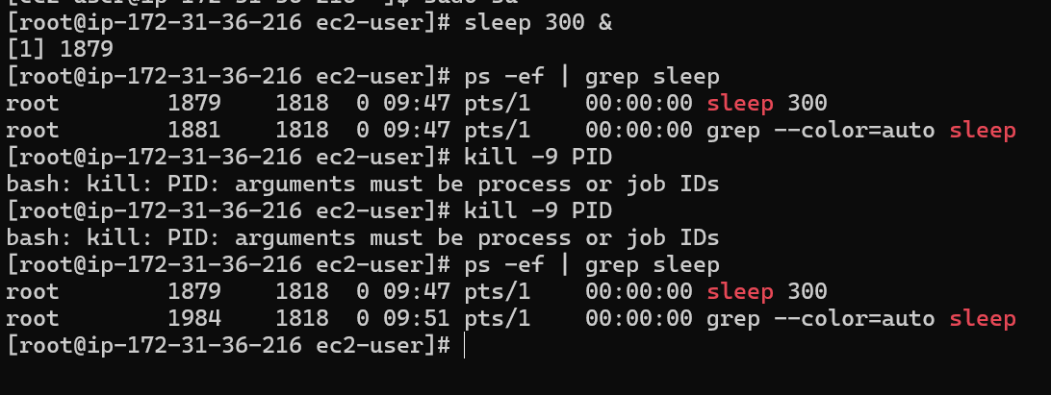
17: Install Package
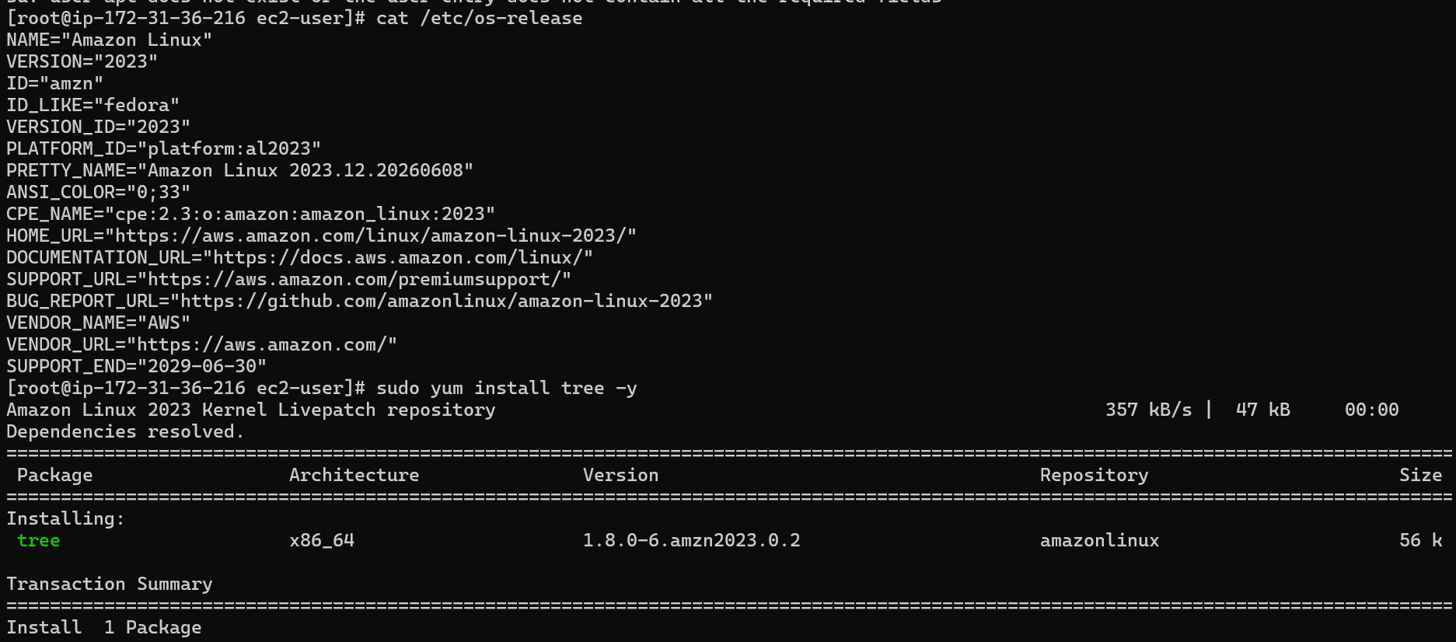
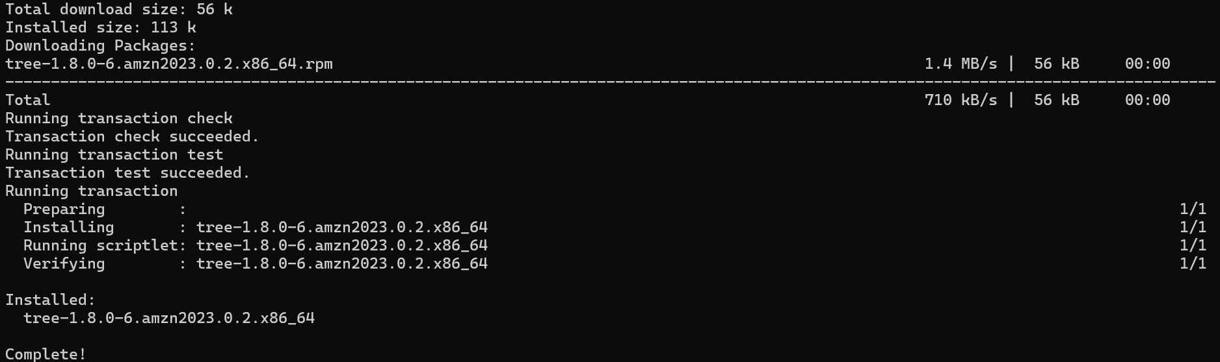

18: Update Packages
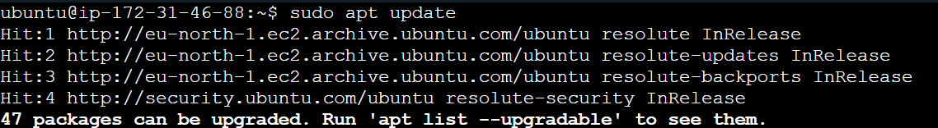
19: Create Symbolic Link
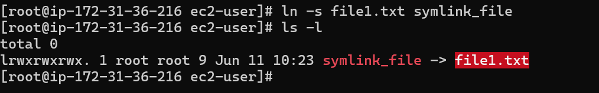
20: Search Files Using Find
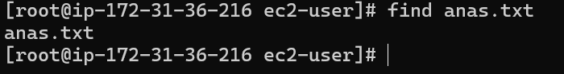
21: Compress and Decompress
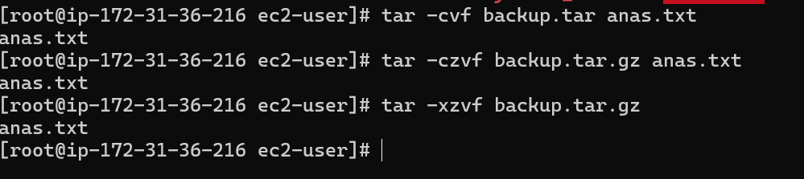

22: Monitor System Resources
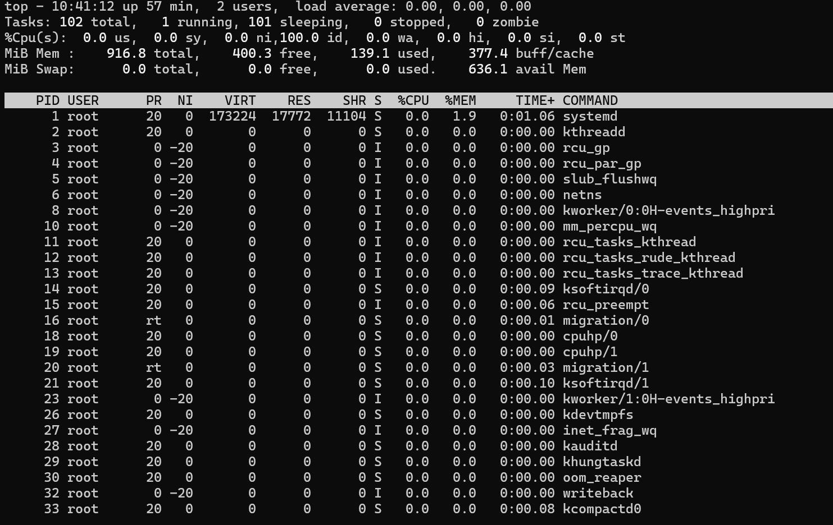
23: Create and Manage Groups
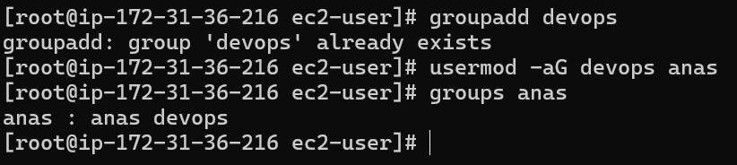
24: SSH passwordless authentication

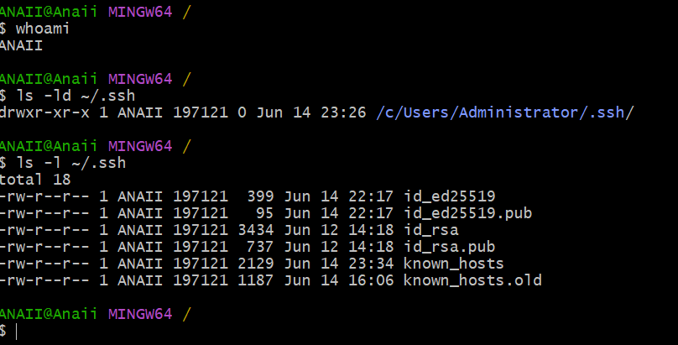
25: Monitering logs using tail or grep
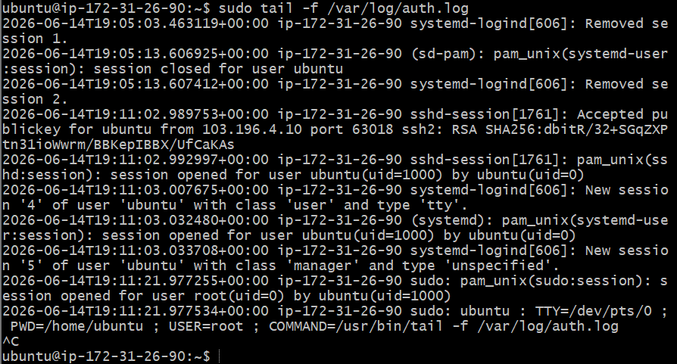
26: Set up web server apache
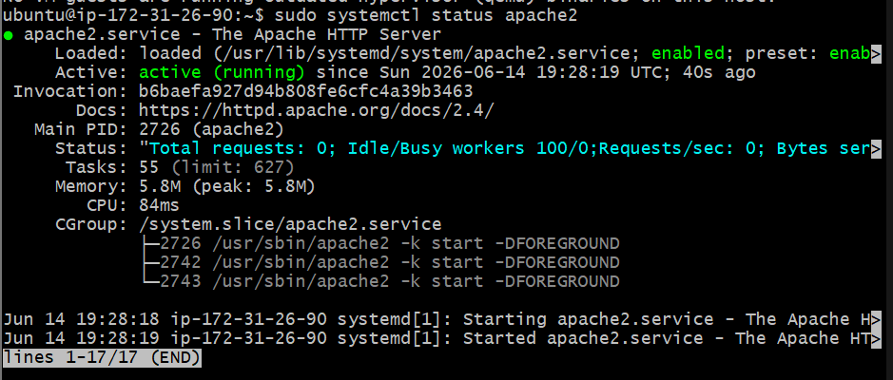
27: Configure and secure MySQL
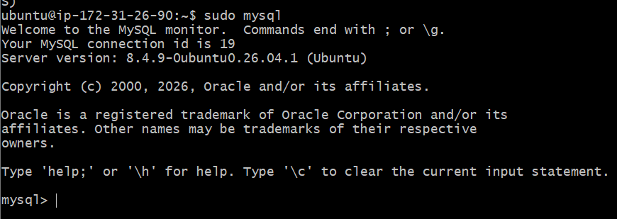
28: Setting up Application server Tomcat
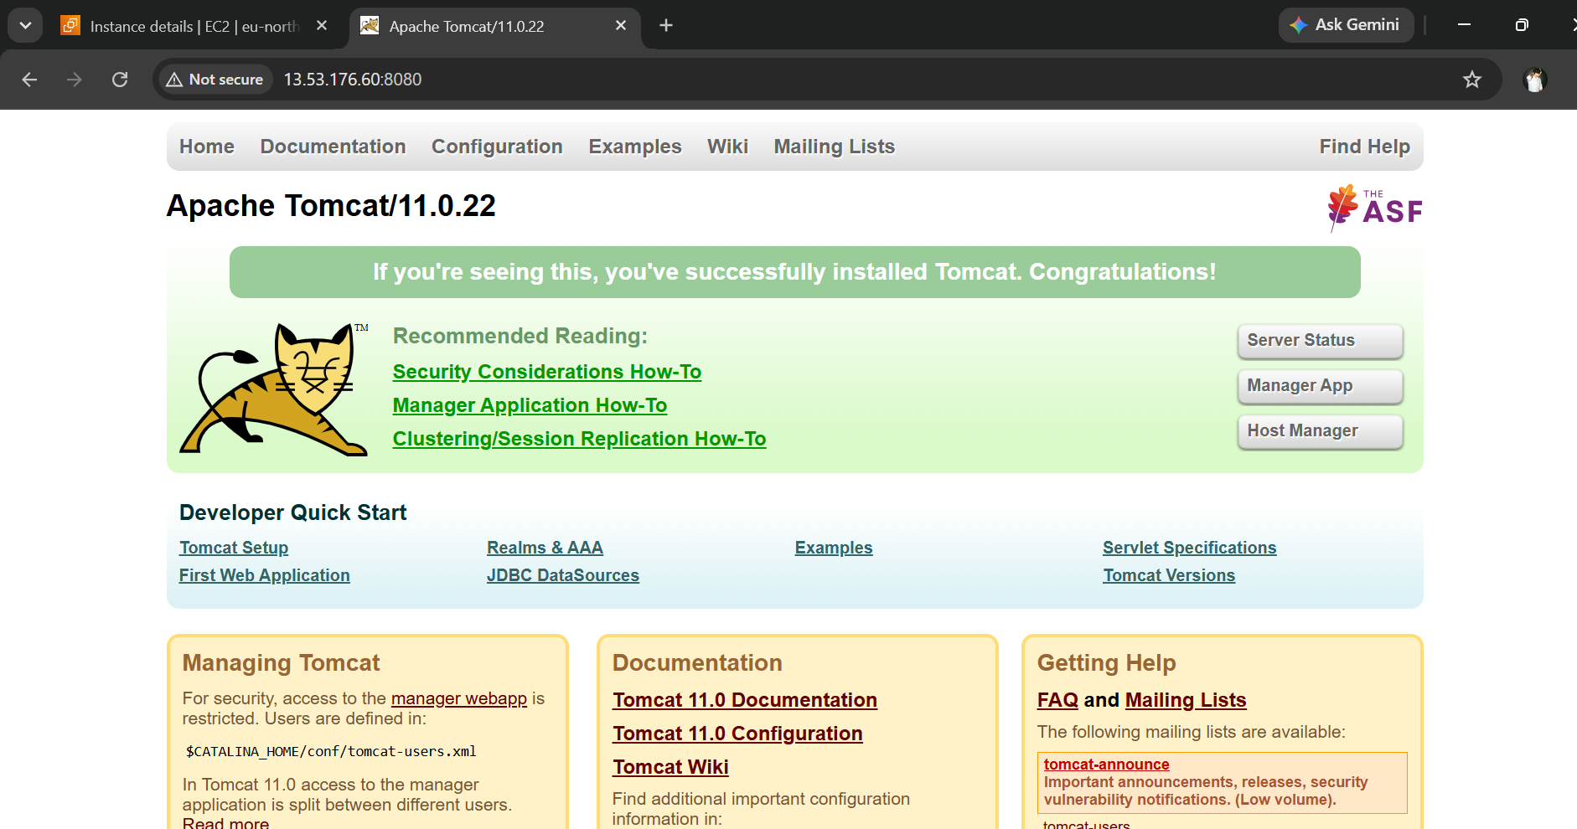
29: created tomcat service file
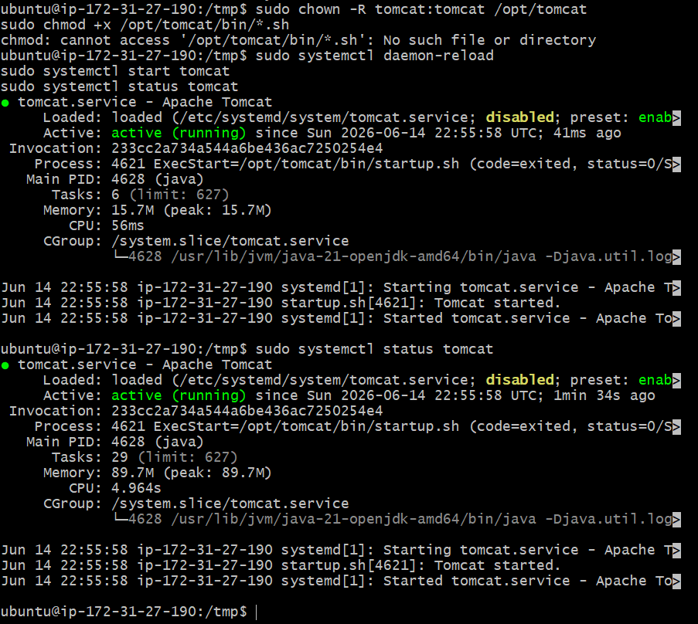
30: Print specific columns from a delimited file.
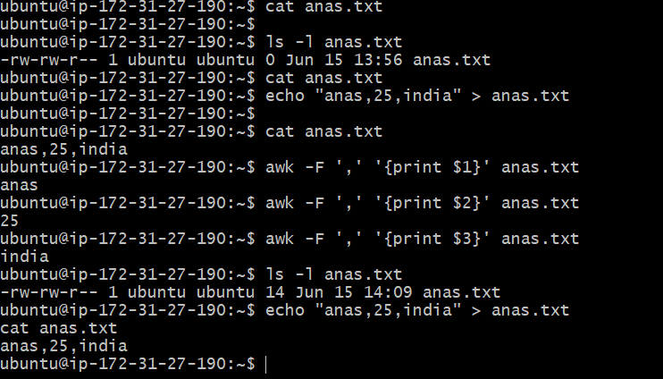
31: Filter and print lines based on a specific pattern or condition.
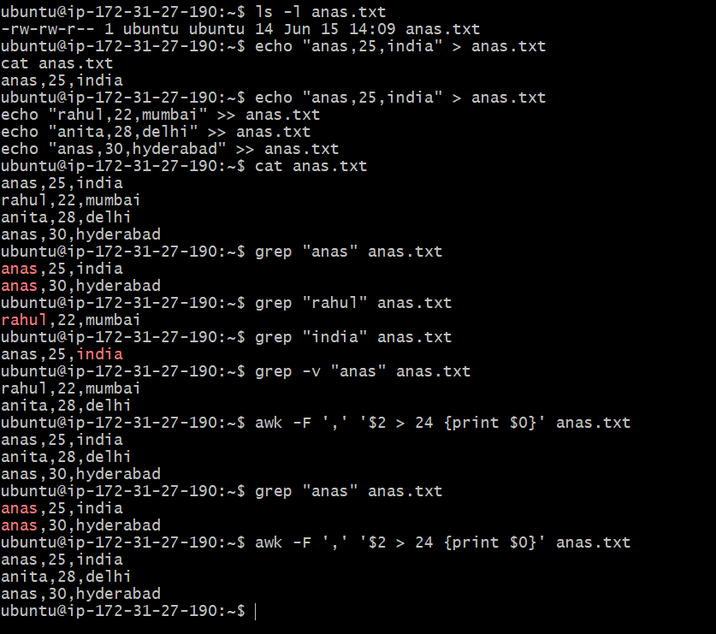
32: Calculate and print the average, sum, or other statistics of a column.
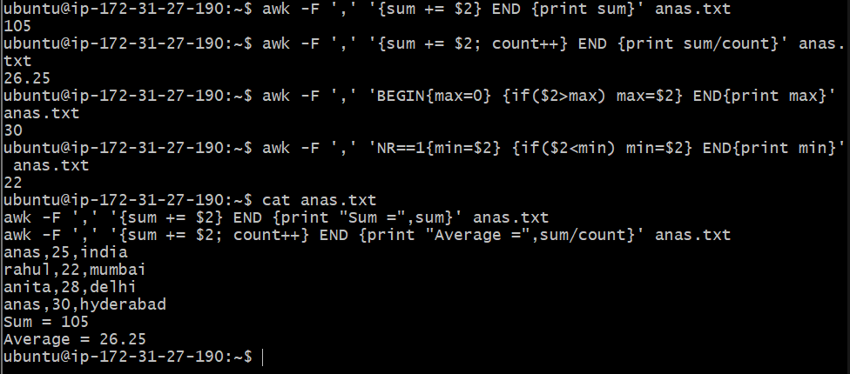
33: Perform string manipulation, such as extracting substrings or changing case.
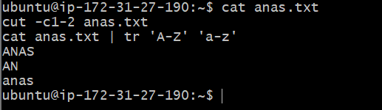
34: Count the occurrences of a specific pattern in a file.
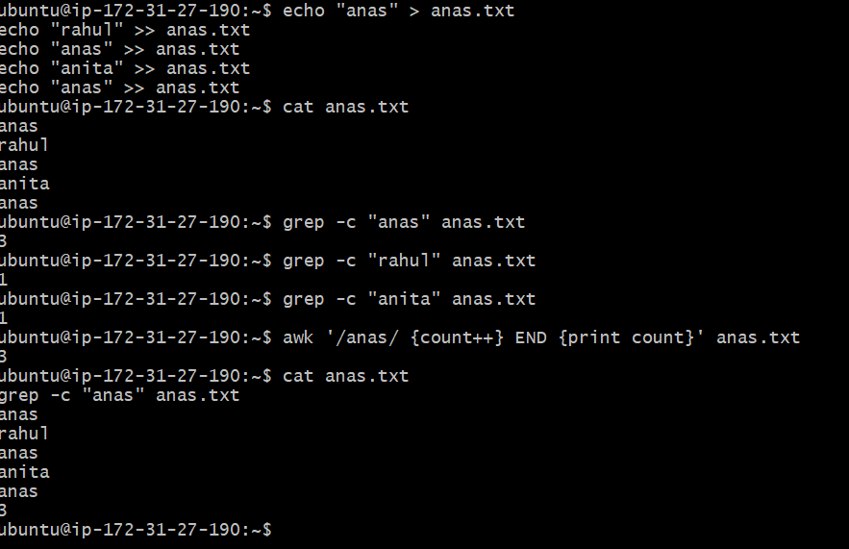
35: Sort lines based on a specific field or column.
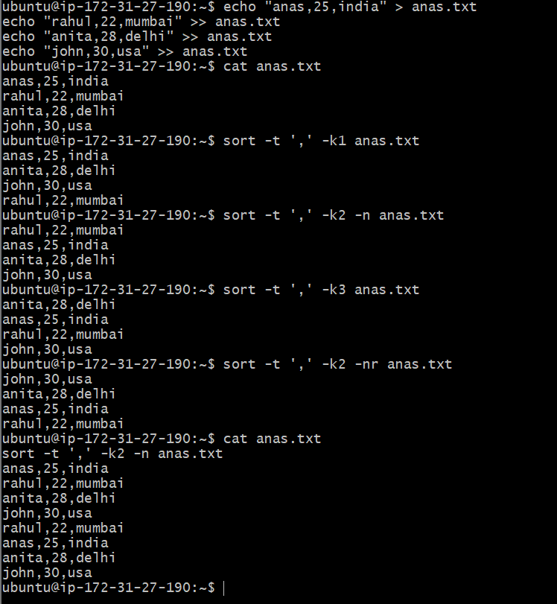

36: Merge multiple files based on a common field or column.
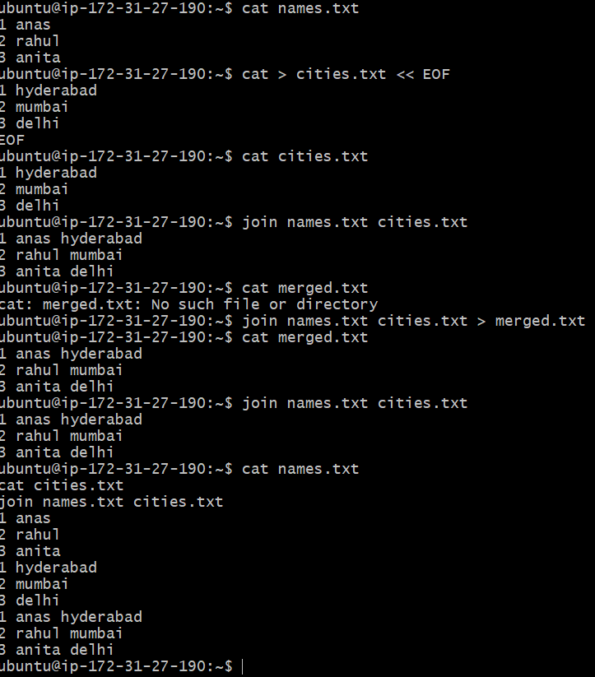
37: Substitute text in a file using search and replace.
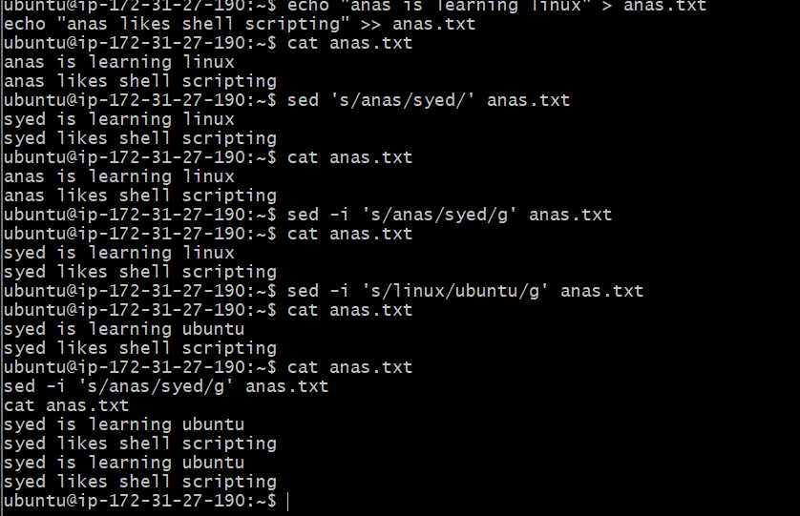
38: Delete specific lines based on a pattern or line number.
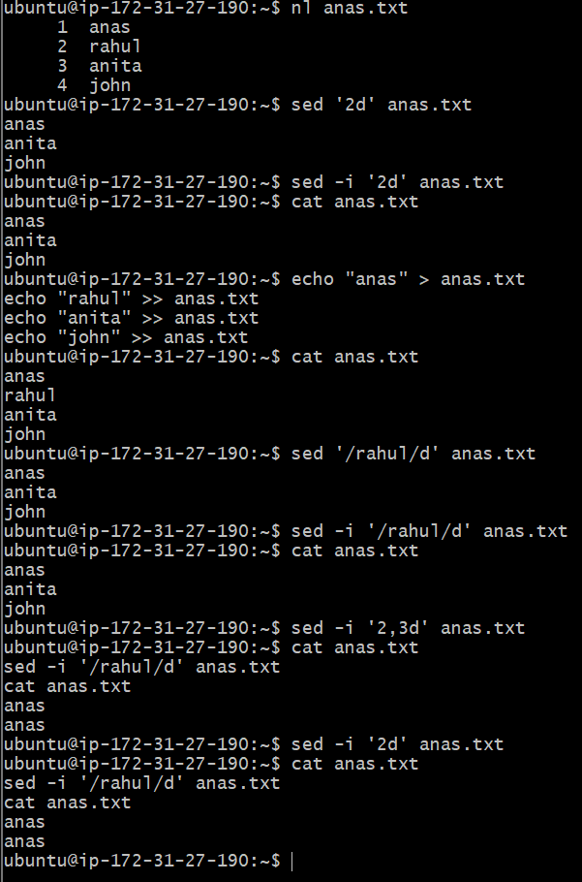
39: Append or insert text before or after a specific pattern or line.
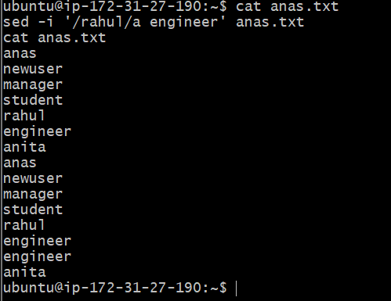
40: Print only specific lines from a file.
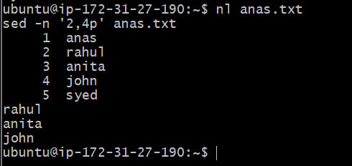
41: Copy file from linux to windows machine
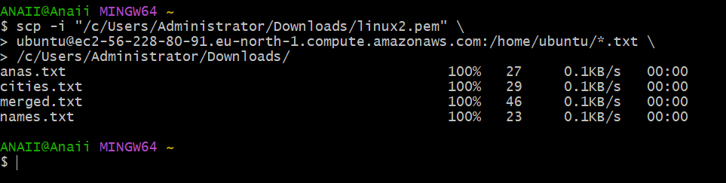
42: 5 use cases for AWK and 5 use cases for sed
